Prerequisites

Software

|  |  |
| --- | --- |
| Assignment Date | 14 November 2022 |
| Team ID | PNT2022TMID44152 |
| Project Name | Safety Gadget For Child Safety Monitoring & Notification |

**Step 1**: Type python in Google and click on the first link.

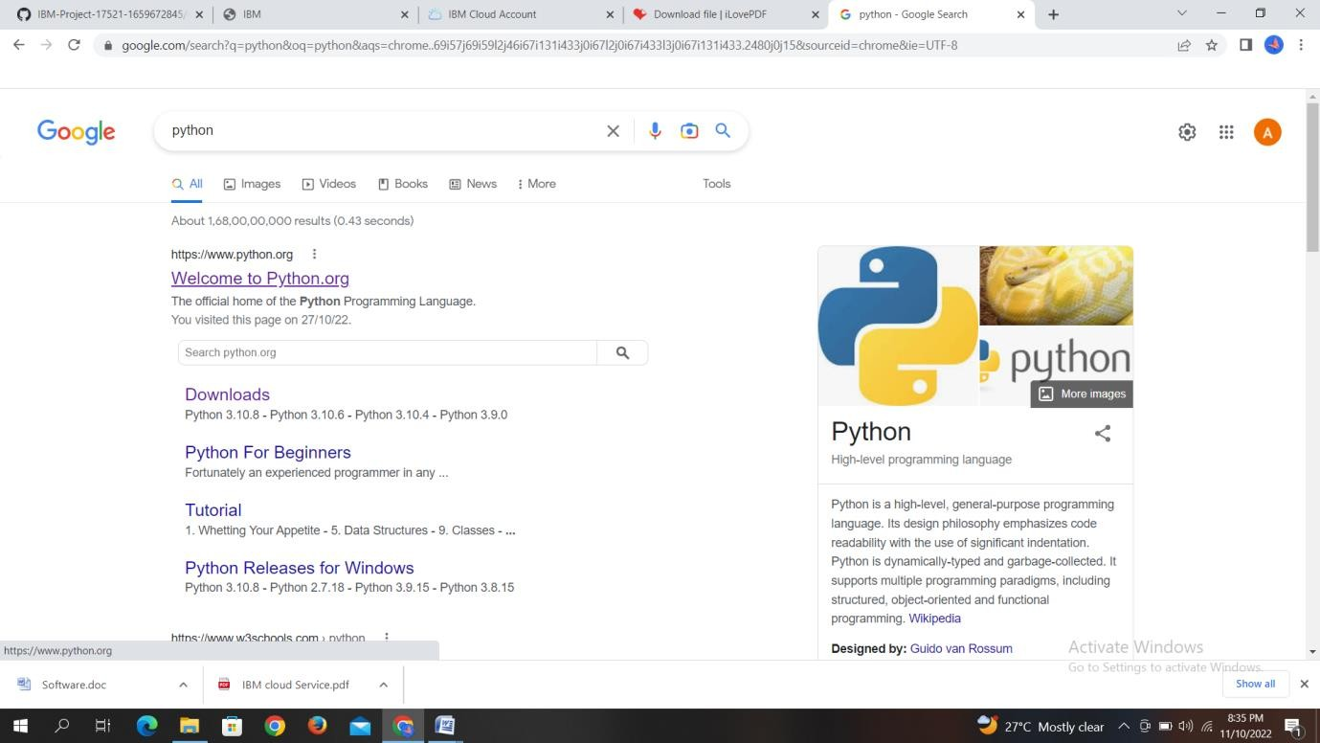

**Step 2:** Click the window x86-64 executable installer

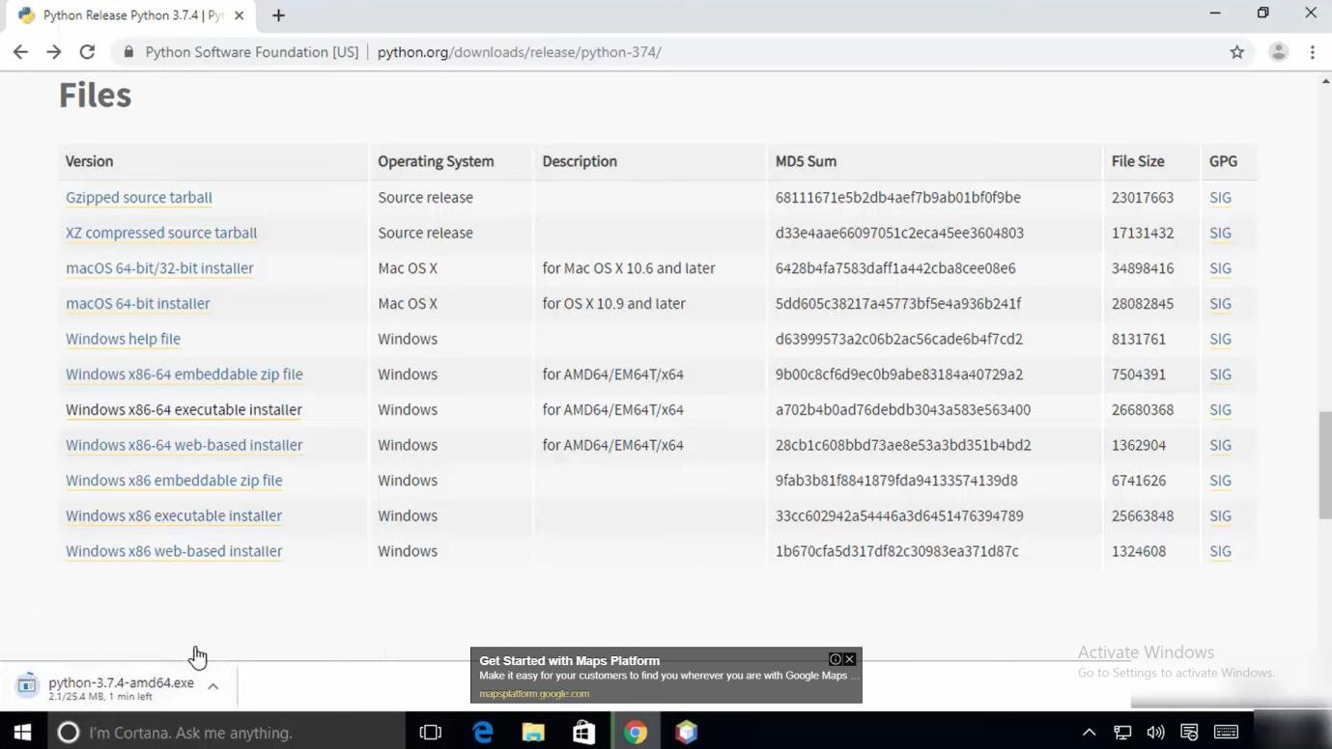

**Step 3**: Click on the Install button.

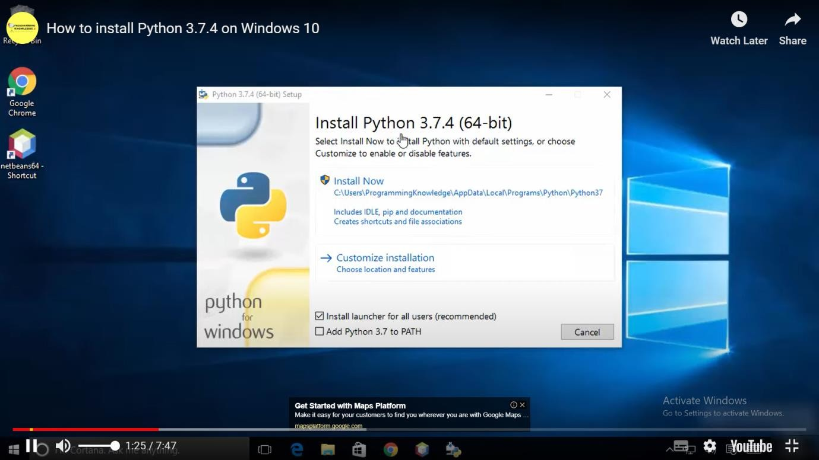

Step 4: Installation on progress

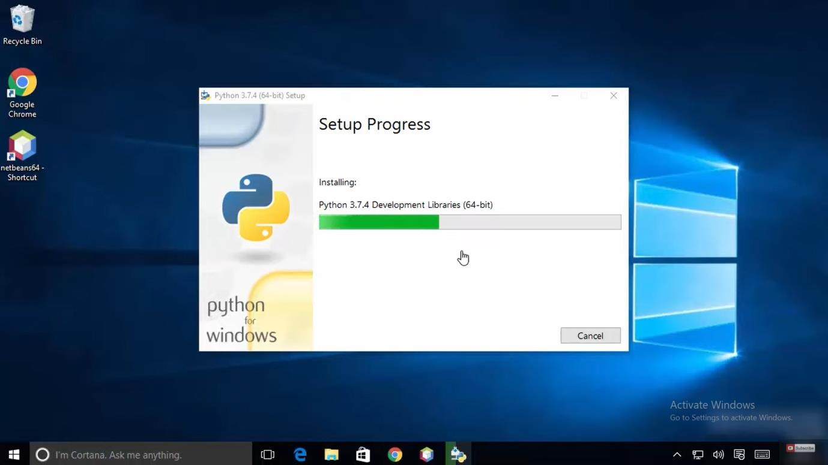

Step 5: Installation Was Successful

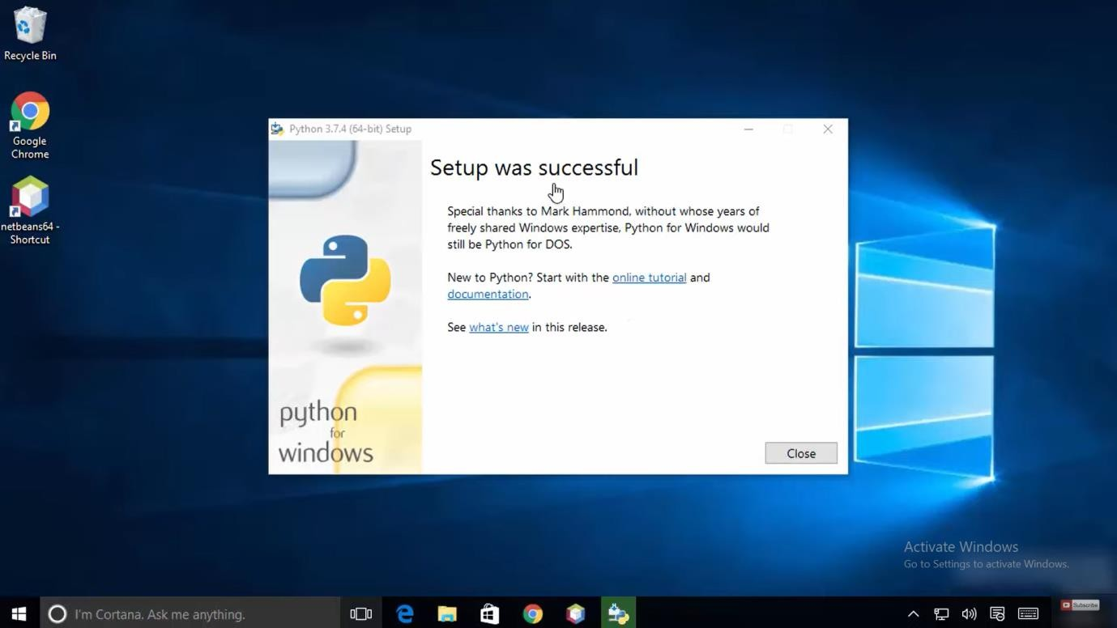

Successfully Installed Python 3.7.4